OSGi lab Practice Report

AgeCalculator

The above table show the result of implementing the AgeCalculator using OSGi. Before executing the AgeCalculator, we have the An OSGi bundle is a deployment module in the form of a JAR file.

So, the we can know the bundles contain class files and resource files, similar to the regular JAR file in Java but in addition they contain manifest information that contains metadata about the bundle. And the AgeCalculatorApi is interface bundle, AgeCalculatorClient bundle is Client bundle, AgeCalculatorImpl is Implementation bundle.

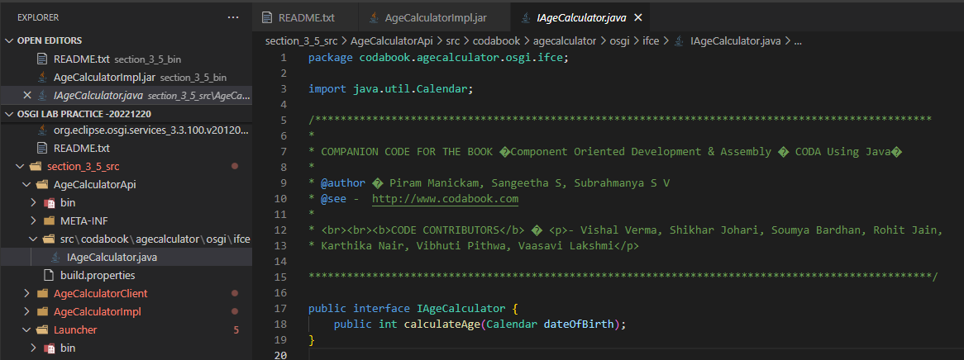

The interface bundle (codabook.agecalculator.osgi.ifce) defines an interface IAgeCalculator. This interface will be used by the implementation bundle to implement the exposed services.

As we can see from the figure above, the Interface bundle is imported and implemented by the implementation bundle. And the client bundle will use the interface for invoking the required services, which gets bounded to the implementation bundle by the service registry like the figure below.

